FORGE FEDRIGA GREEN & SAFETY MAGAZINE N°.17

Information and sharing of environmental and health and safety topics underlie the relationship between Forge Fedriga and all its stakeholders. We are publishing the 17th issue of the “**Green & Safety Magazine**”.

### WHP PROGRAMME - WORKPLACE HEALTH PROMOTION

Forge Fedriga has joined the programme "**Workplaces that promote health-WHP (Workplace Health Promotion) Network**" published by the Ministry of Health and the Lombardy Region and promoted by the Valle Camonica A.T.S. The aim is to reduce the preventable and avoidable illness, mortality and disability burden of CNCDs (Chronic Non-Communicable Diseases). The programme contributes to the processes of health promotion in the workplace, specifically overseeing the prevention of behavioural risk factors for chronic diseases (poor diet, sedentariness, smoking, harmful alcohol consumption). Membership requires the company to register in the course of 2022, which will be followed by the planning of a good practice path described in a manual.

Practices such as, for example, promoting active mobility on the home-work route, carrying out physical activity, supporting tobacco cessation, healthy eating behaviour in the company canteen and for food distributors. These actions, to be planned over the next three years, will be reported and monitored by A.T.S. which, after the appropriate checks and inspections, will issue a certificate of recognition as a "**Workplace Health Promotion**".

### 

**AUTONOMOUS REGION**

**FRIULI VENEZIA GIULIA**

**Region**

**Lombardy**

MANUAL FOR THE IMPLEMENTATION OF THE PROGRAMME **"WORKPLACE HEALTH PROMOTION - WHP NETWORK"**

**Workplace Health Promotion**

### PROJECT “A CYCLE-ABLE VALLEY”

In 2021 Forge Fedriga expressed its interest in the project “A cycle-ABLE Valley: experimenting with active mobility routes” presented by the **Valle Camonica Bio-district**. The Company is among the technical sponsors with Local Authorities and Municipalities.

The project was approved by the CARIPLO Foundation on 10/12/2021 and will participate with a share of the € 47,000. The aim is to promote mixed and integrated mobility, which is active in order to improve the quality of air and the quality of life of residents. Actions include, for example, creating a favourable environment for cycling to work if possible (incentives with the use of the app, mileage reimbursement, electric charging stations, bike repair bonus, agreements with companies, etc.)

### 

“GREEN” INNOVATIONS IN CATERING AND COFFEE BREAKS

The company's environmental policy is becoming increasingly green, implementing initiatives to raise awareness among employees and suppliers of the use and consumption of products that have a reduced impact on the environment. Specifically, this was done as follows:

**Suppliers:** analysis of the purchase of a product, not only on a monetary basis but also in relation to the environmental impacts that this product may have throughout its life cycle.

**Employees**: new arrangements related to the canteen, beverage dispensers and coffee machines, namely:

**Canteen**

* All material supplied by the canteen becomes 100% compostable, so it should be placed in the organic waste bin.
* Removal of water bottles provided for meals in favour of the use of personal water bottles for the consumption of natural and sparkling water, dispensed from dispensers.

**Coffee machines and vending machines**

* For the hot drinks part, the cup and scoop are completely biodegradable, so they should be placed in the organic waste bin.
* Possibility of using a personal cup and thus reducing first of all the waste produced and not least the total cost of the drink.
* Progressive reduction in the number of plastic water bottles in dispensers to encourage the use of personal refillable water bottles in the various dispensers.

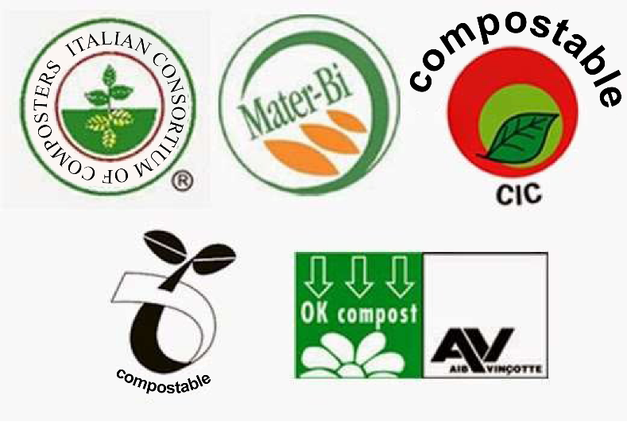

ECO-FRIENDLY OFFICE: ADOPTION OF RECYCLED PAPER

Despite the fact that we are in the midst of the digital age, paper consumption shows no sign of decreasing. The office is one of the places where most paper is used and often wasted. Forge Fedriga has decided to pursue its green policy here as well, choosing to use paper completely obtained from separate waste collection.

Choosing paper from separate waste collection not only combats deforestation but also reduces water and energy consumption. Using recycled paper does not affect the quality of our work and at the same time minimises the environmental effects of the primary paper production cycle, which are not negligible. It takes 15 trees, 440,000 litres of water and 7600 Kwh of electricity to produce one tonne of new paper. The production of recycled paper, on the other hand, not only does not cut down trees, but energy consumption is reduced by half and water consumption by up to 80%. We also save the environment about 84% of the carbon dioxide emissions that would be released into the atmosphere if the same paper were made from pure pulp. Not only that, by using paper that comes from recycling, particularly post-consumer recycled paper (i.e. from the bin and not from scrap), we are also contributing to a reduction in the volume of waste that would otherwise end up in landfill, thereby promoting its recovery.

